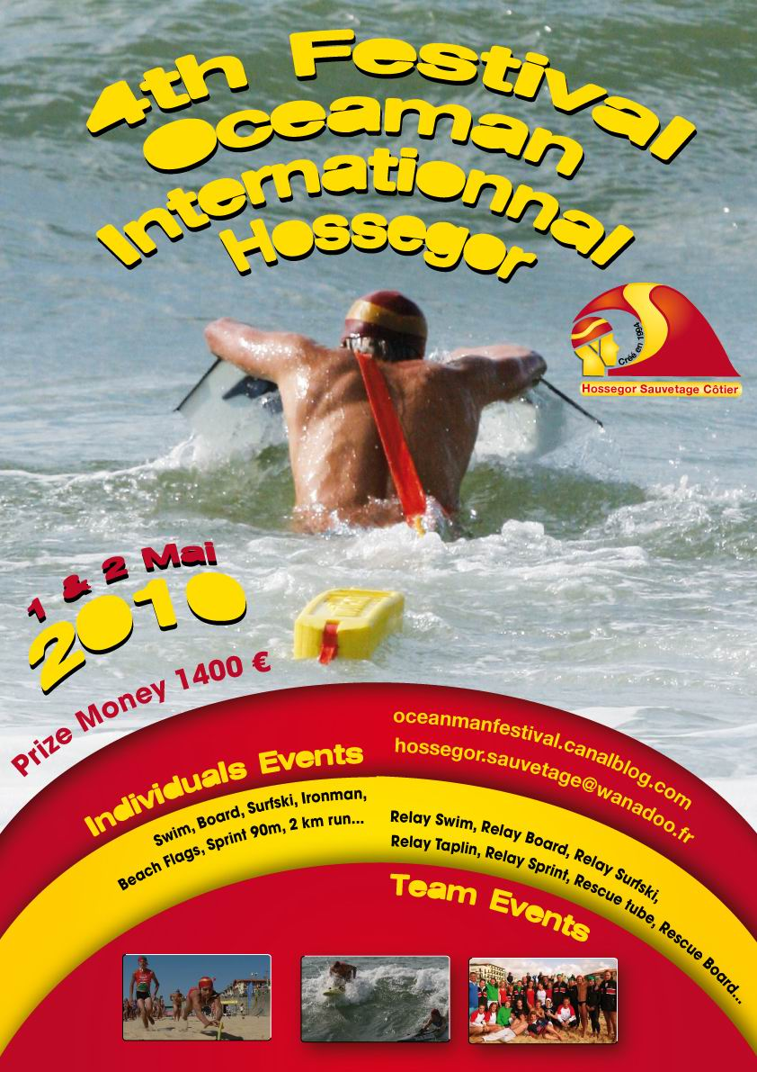

RULES

The Festival Oceanman International is organised by Hossegor Sauvetage Côtier. It will take place on Hossegor central beach on the 1st and 2nd of may 2010.

EVENTS

INDIVIDUAL EVENTS | TEAM EVENTS
Beach flags | Relay sprint (3 lifesavers)
Sprint | Relay tube (4 lifesavers)
2km run | Rescue board (2 lifesavers)
Swim | Relay swim (3 lifesavers)
Board | Relay board (3 lifesavers)
Surf ski | Relay surf ski (3 lifesavers)
Oceanman | Relay taplin (3 lifesavers)

COMPETITORS AND TEAMS

The Festival Oceanman International is open to all I.L.S. members and F.F.S.S. members, whatever their age.

INDIVIDUAL EVENTS

All events will be raced in a single age category “open”. All under 18 competitors should provide an authorization of their club manager and they should come with an adult.

TEAM EVENTS

In a team, the number of competitors is not limited. However, a team cannot present more than 3 relays par event. The team could represent a city, a region, a nation, a selection between competitors from different clubs or countries. She should have a precise name and a responsible captain. A team can engage different relays on several events. A male/female relay will compete in an event with the male relays.

REGISTRATION

Each competitor must pay a 15 euro fee to race the event. Entry fees and engagement forms should be returned to Hossegor Sauvetage Côtier before the 23th of april 2010. Late entry fees will be raised by a 10 euro penalty.

Address : Hossegor Sauvetage Côtier
78 avenue des Tonneliers
40150 HOSSEGOR
FRANCE

E-mail : hossegor.sauvetage@wanadoo.fr

EQUIPMENT

Competitors will make sure they have the necessary equipment before entering the event. Each club will organize the equipment rotation among it’s teams to avoid disturbing the competition. Equipment problems shouldn’t late the race. Equipment must meet the standards approved by I.L.S. Competitors shall wear identical team swim caps. These swim caps securely fastened under the chin must be worn at the start of each event. The team lycra tops are recommended but not compulsory during the event.

CLASSIFICATION

There will be a classification and a podium for each individual and relay event. By the end of the competition, the overall scored points will determine the females, males, female teams, male teams and teams that have been the most regular during the competition.

General classification individual females and males : It will be established by adding the points earned by each lifesaver during individual events to determine the best female and male lifesavers.

General classification female and male relays : It will be established by adding the points earned by each team during relays events to determine the best female and male teams.

General classification interclubs : It will be established by adding the points earned by each lifesaver during individual and relays events to determine the best teams.

INVIDUAL CLASSIFICATION POINTS

1st place | 20 points | 7th place | 12 points | 13th place | 4 points
2nd place | 18 points | 8th place | 11 points | 14th place | 3 points
3rd place | 16 points | 9th place | 8 points | 15th place | 2 points
4th place | 15 points | 10th place | 7 points | 16th place | 1 point
5th place | 14 points | 11th place | 6 points
6th place | 13 points | 12th place | 5 points

TEAM CLASSIFICATION POINTS

1st place | 40 points | 7th place | 24 points | 13th place | 8 points
2nd place | 36 points | 8th place | 22 points | 14th place | 6 points
3rd place | 32 points | 9th place | 16 points | 15th place | 4 points
4th place | 30 points | 10th place | 14 points | 16th place | 2 points
5th place | 28 points | 11th place | 12 points
6th place | 26 points | 12th place | 10 points

DIVERSE

- 10 points will be allocated to each team for participating.

- For individual events, only the points earned by the three first lifesavers will count for interclub classification. Past the three first ones, the other members of the team are blocking the points.

- For relay events, 3 relays can be raced per team but only the points of the first one will count for interclub classification.

- Ties in overall point scores shall be broken using the following system : most first-place final finishes, most second-place final finishes,…

PRIZE MONEY

The total prize money of 1400 euros will award the best lifesavers and the best teams of that competition. The share will be done as indicated below (price in euro) :

 | 1st | 2nd | 3rd | 4th | 5th
General classification individual females | 100 | 70 | 50 | 40 | 30
General classification individual males | 100 | 70 | 50 | 40 | 30
General classification female relays | 100 | 80 | 60 | - | -
General classification male relays | 100 | 80 | 60 | - | -
General classification interclubs | 150 | 110 | 80 | - | -

OFFICIALS / RACE COMMITTEE

Each club shall delegate at least one accredited lifesaver to the race committee which will meet on the evening prior to the event. Referees and judges are required to attend the appropriate briefings to review judging sheets and event procedures.

INFORMATIONS
Web site : http://oceanmanfestival.canalblog.com/

E-mail : hossegor.sauvetage@wanadoo.fr

Phone number : +33 (0)5.58.43.74.74

Address : Hossegor Sauvetage Côtier
78 avenue des Tonneliers
40150 HOSSEGOR
FRANCE

